Here are some of the key beliefs shared among Hindus:

Truth is eternal. ...

Brahman is Truth and Reality. ...

The Vedas are the ultimate authority. ...

Everyone should strive to achieve dharma. ...

Individual souls are immortal. ...

The goal of the individual soul is moksha.

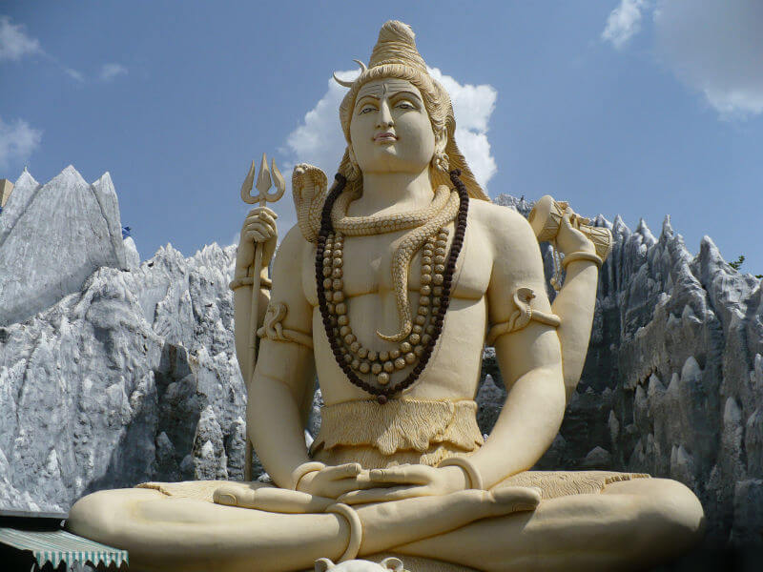

The written syllable ॐ called omkara serves as a deeply significant and distinctly recognizable symbol for Hindu dharma. The pronunciation of Aum moves through all possible human linguistic vowel sounds and is different from the pronunciation of Om.

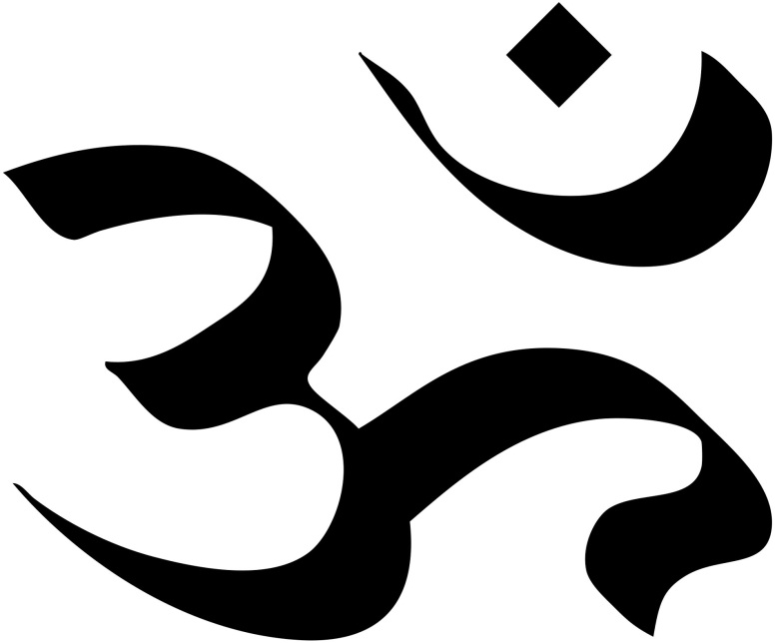

Most scholars believe Hinduism started somewhere between 2300 B.C. and 1500 B.C. in the Indus Valley, near modern-day Pakistan. But many Hindus argue that their faith is timeless and has always existed. Unlike other religions, Hinduism has no one founder but is instead a fusion of various beliefs.Oct 6, 201

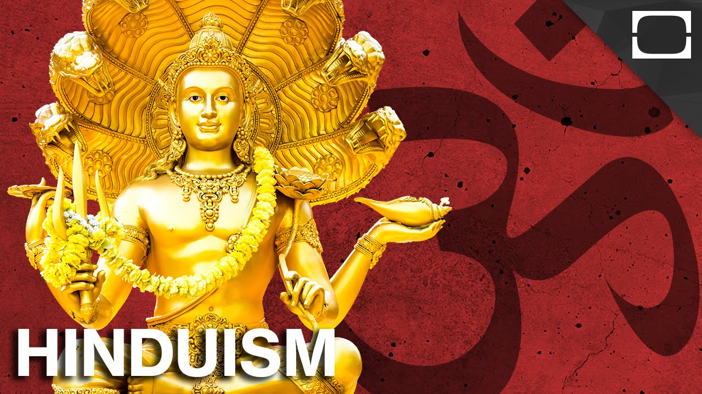

Hinduism is the world's third most popular religion, with around 750 million followers. The religion of Hinduism originated in Northern India, near the river Indus, about 4000 years ago and is the world's oldest existing religion. Hinduism is practised by more than 80% of India's population.

Sacred Text: Vedas, Upanishads

Place of Origin: India

Founder: Developed out of Brahminism

Sacred Building: M1500 B.C.

Most scholars believe Hinduism started somewhere between 2300 B.C. and 1500 B.C. in the Indus Valley, near modern-day Pakistan. But many Hindus argue that their faith is timeless and has always existed. Unlike other religions, Hinduism has no one founder but is instead a fusion of various beliefs.Oct 6, 2017andir

Shaivism is one of the major traditions within Hinduism that reveres Shiva as the Supreme Being. The followers of Shaivism are called "Shaivites" or "Saivites". It is one of the largest sects that believe Shiva — worshipped as a creator and destroyer of worlds — is the supreme god over all.

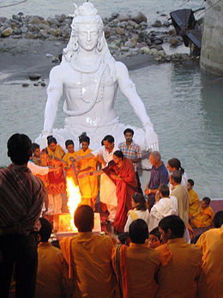

Shaktism

Description

Shaktism is a major tradition of Hinduism, wherein the metaphysical reality is considered metaphorically feminine and Adi Parashakti is supreme. It includes a variety of Goddesses, all considered aspects of the same supreme Goddess

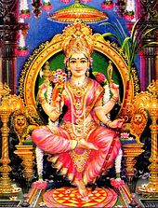

Vaishnavism

Denomination

Description

Vaishnavism is one of the major Hindu denominations along with Shaivism, Shaktism, and Smartism. It is also called Vishnuism, its followers are called Vaishnavas or Vaishnavites, and it considers Vishnu as the Supreme Lord

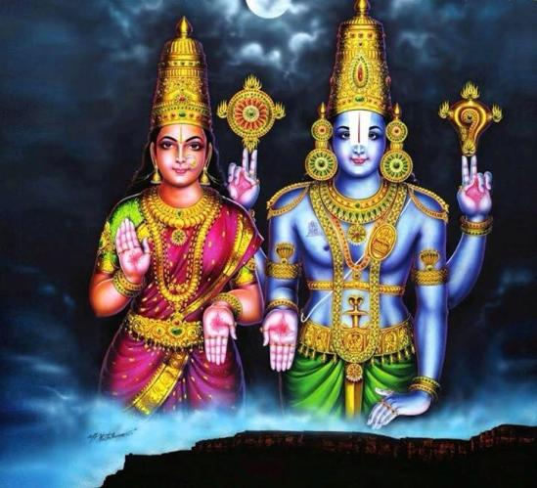

Smarta tradition

Philosophical belief

Description

Smarta tradition is a movement in Hinduism that developed during its classical period around the beginning of the Common Era. It reflects a Hindu synthesis of four philosophical strands: Mimamsa, Advaita, Yoga, and theism. Wikipedia

Feedback

